AIRCDRE Margot Forster, CSM
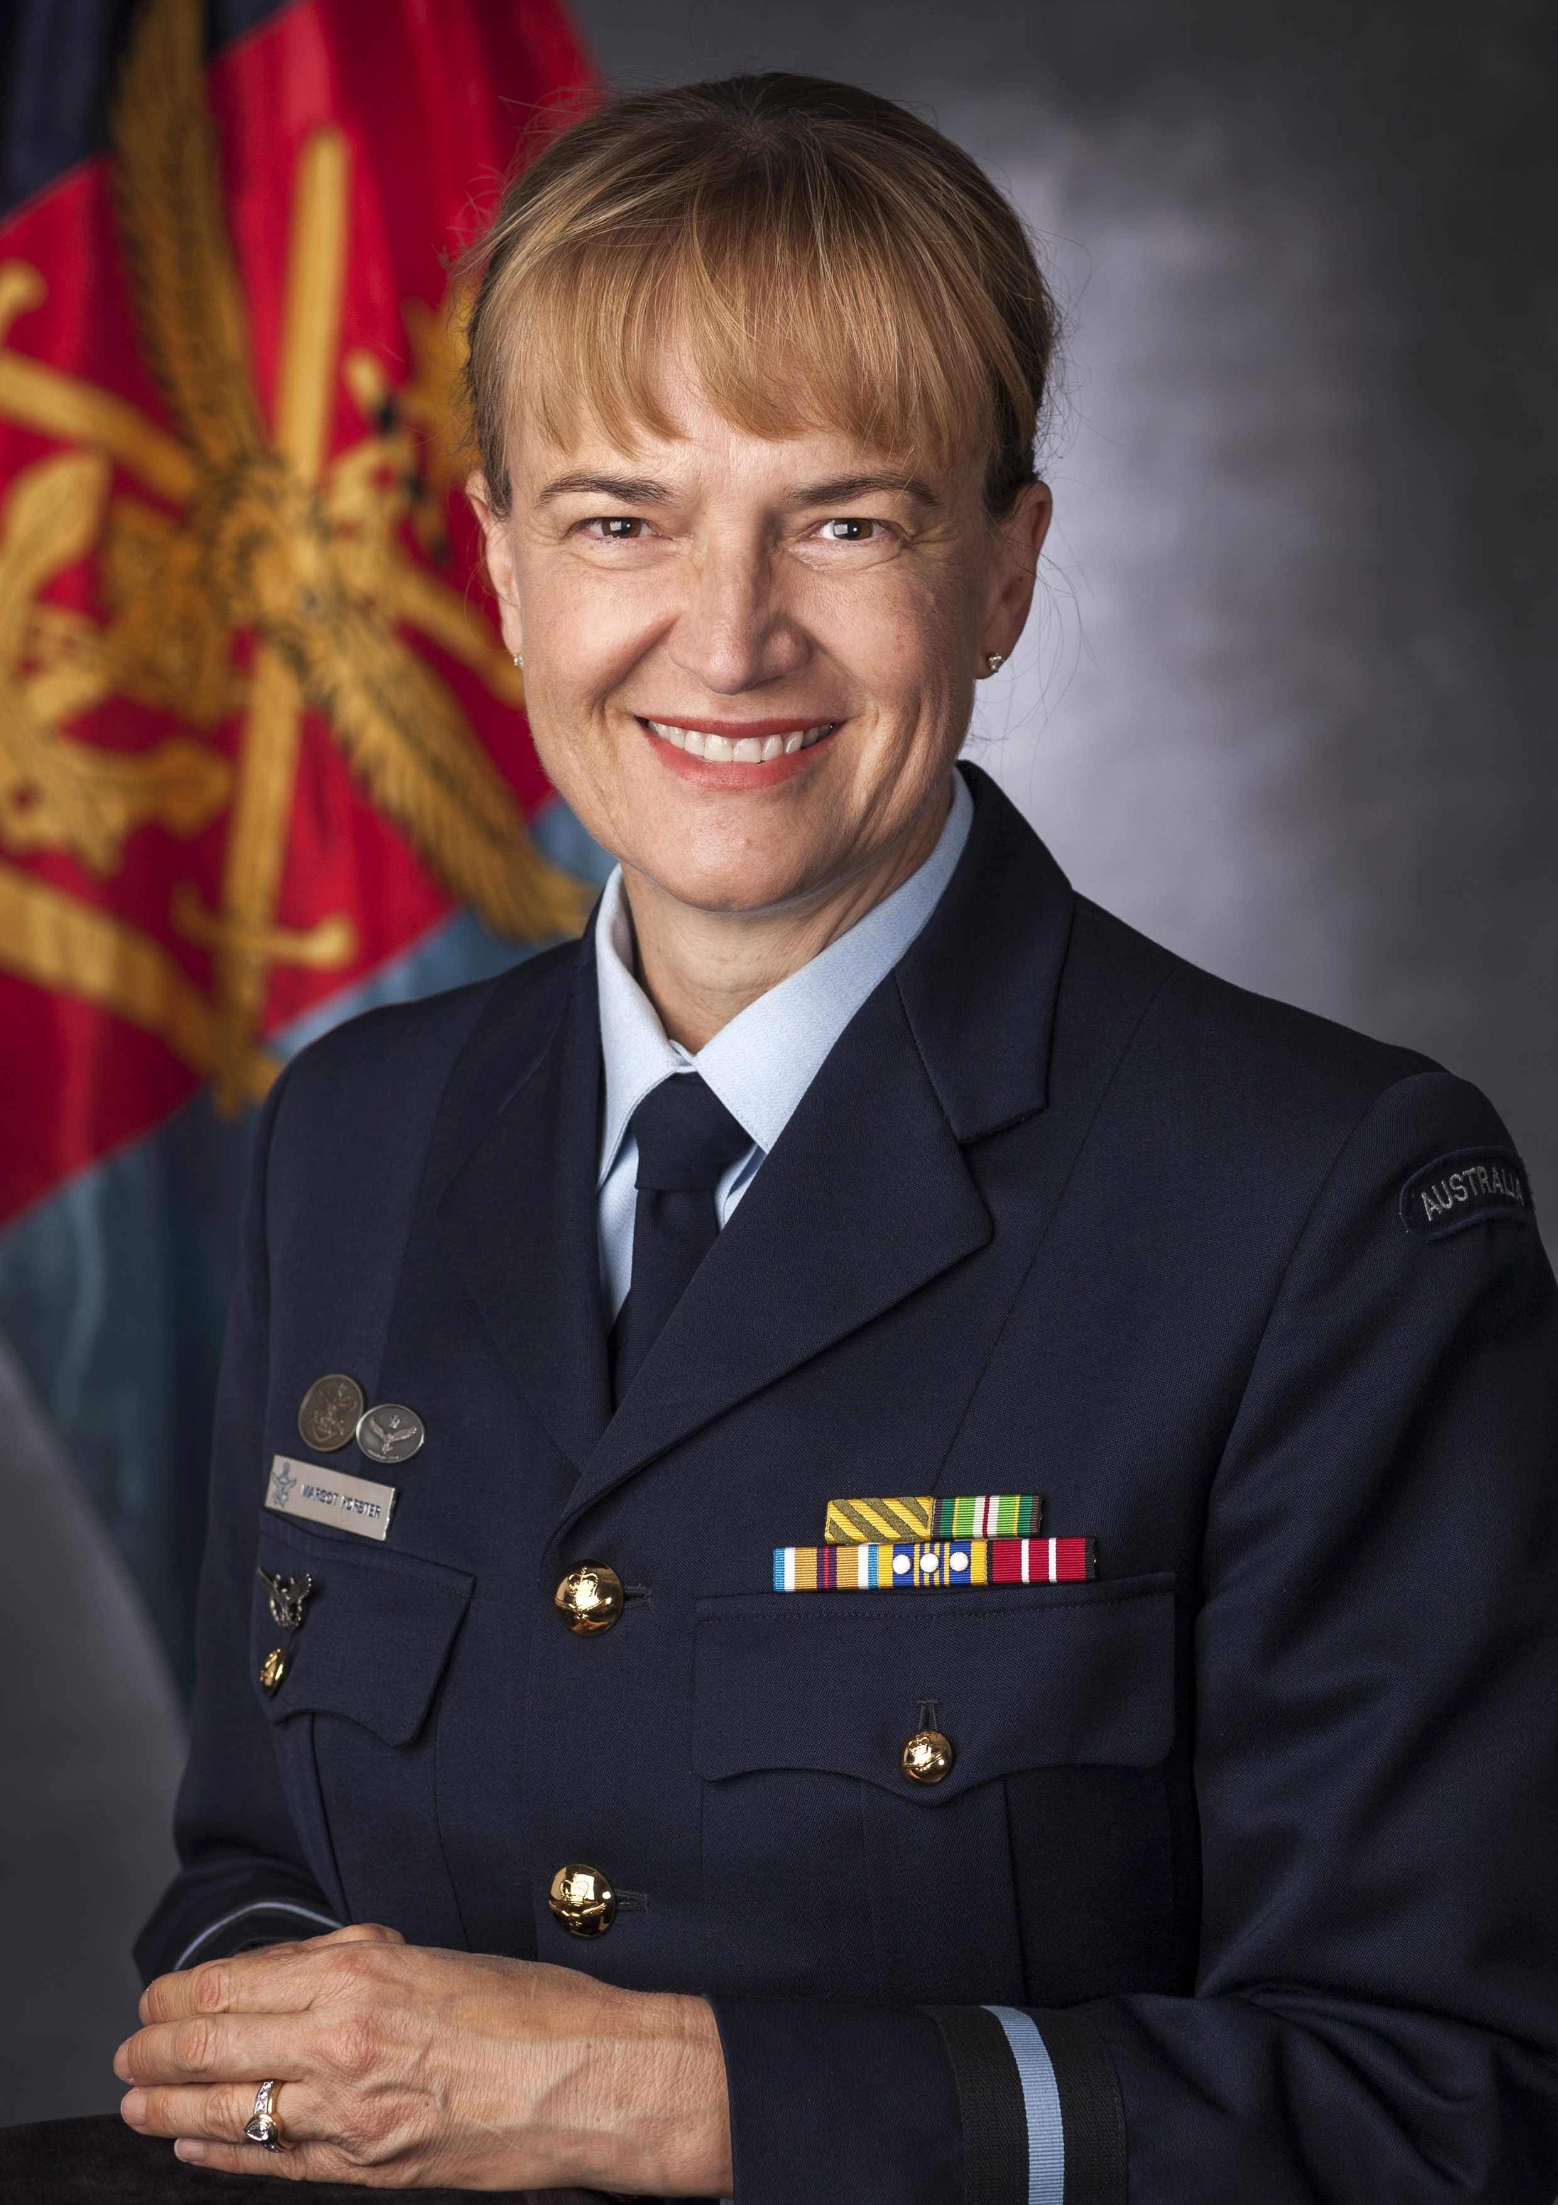
COMMANDANT, AUSTRALIAN COMMAND AND STAFF COLLEGE
Born in Adelaide, Air Commodore Margot Forster joined the Royal Australian Navy (RAN) in August 1982. On graduation from the RAN Naval College and completion of Supply Officer training, she undertook a number of junior Supply Officer roles ashore and at sea before transferring to the Royal Australian Air Force (RAAF) in late 1988.
Having transferred to the RAAF as an Administration Officer, Air Commodore Forster served in various Unit administrative positions at RAAF Williamtown and Edinburgh. Air Commodore Forster took a short leave of absence from the RAAF in 1992 and took up employment with the Department of Foreign Affairs and Trade as a Senior Administrator in the Australian Embassy, Washington DC. In May 1995 Air Commodore Forster returned to Australia and full-time work within the RAAF to work in Air Force Materiel Division.
Over the next ten years Air Commodore Forster specialised in organisational reform and design, and workforce transition, supporting a number of workforce reform projects including the Chief of Air Force's Rebalance and Reshape Program. January 2007 saw Air Commodore Forster's focus shift to combat support when she was appointed as the Base Commander RAAF Base Williams and Commanding Officer Combat Support Unit Williams, for which she was awarded a Conspicuous Service Medal on the 2009 Queens Birthday Honours List.
In 2009, Air Commodore Forster joined Aerospace Operational Support Group as the Staff Officer Personnel, and later the Chief of Staff. Air Commodore Forster deployed to the Middle East Area of Operations in November 2010 as the Commanding Officer Combat Support Unit, Al Minhad Air Base. Her efforts on this deployment saw her awarded a Chief of Joint Operations Gold Commendation for 'contribution to significant improvements to support for forces engaged in combat operations'. Other awards include commendations from the Chief of Air Force and Assistant Chief of Materiel - Air Force for her contribution to workforce reform and for project management.
In May 2012 Air Commodore Forster was promoted to Group Captain and appointed as Director, Pathway to Change. In this position she was responsible for coordination, reporting and oversight of Pathway to Change implementation within Air Force. Air Commodore Forster served in this role until January 2013 when she took up the position of Chief of Staff Air Force Personnel Branch. Air Commodore Forster is a graduate of the Centre for Defence and Strategic Studies (2015), with a Masters of Arts in Strategic Studies. Air Commodore Forster was promoted and appointed to her current post of Commandant, Australian Command and Staff College in December 2015.
Air Commodore Forster is married to Mike and they have three children, Rebecca, Christopher and Matthew.

