Mr Gary Quinlan
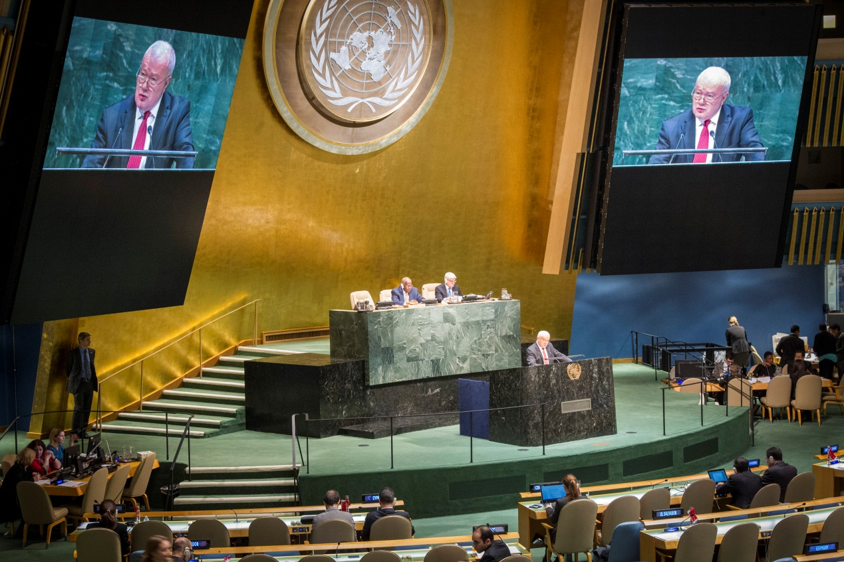

Deputy Secretary
Mr Gary Quinlan is a Deputy Secretary in the Department of Foreign Affairs and Trade. He was Australia’s Ambassador and Permanent Representative to the United Nations in New York from 2009 until January 2015, and Australian Representative on the United Nations Security Council 2013-2014. He was President of the Security Council in September 2013 and November 2014. He was Principal Adviser to the Prime Minister on Foreign Affairs, Defence and National Security late 2007-2009. Mr Quinlan has served in several senior positions in the Department in Canberra with responsibility for areas including East Asia, the Americas and Europe, and in management. He was in charge of Australia’s operational response to the East Timor crisis in 1999. He was a lead negotiator for Australia in the 1980s in international negotiations on law of the sea, and on Antarctic matters. His overseas assignments before his recent one in New York have been as Deputy in the Australian Embassy in Washington DC, 2005-2007; High Commissioner (Ambassador) to Singapore, 2001-2005; First Secretary, Australian Mission to the United Nations, New York, 1981-1985; Australian Deputy Permanent Delegate to UNESCO, Paris 1979-1981; and Second Secretary in the Australian Embassy in Dublin, 1974-1977. He was short-term at the Economic Development Institute at the World Bank in Washington DC in 1984. Mr Quinlan also served as Chief of Staff to the Minister for Resources, 1989 -1991; to the Minister for Industrial Relations, 1991-1993; to the Minister for Trade, 1993; and to the Minister for Industry, Science and Technology, 1994-1996. He has a B.A (Hons) from the University of Newcastle and an Hon D. Litt (Newcastle), 2007.

